**NETFLIX CASE STUDY**

**Insights:**

1. Anupam Kher has starred in the maximum number of Movies and TV Shows on Netflix followed by Shah Rukh Khan and Julie Tejwani.

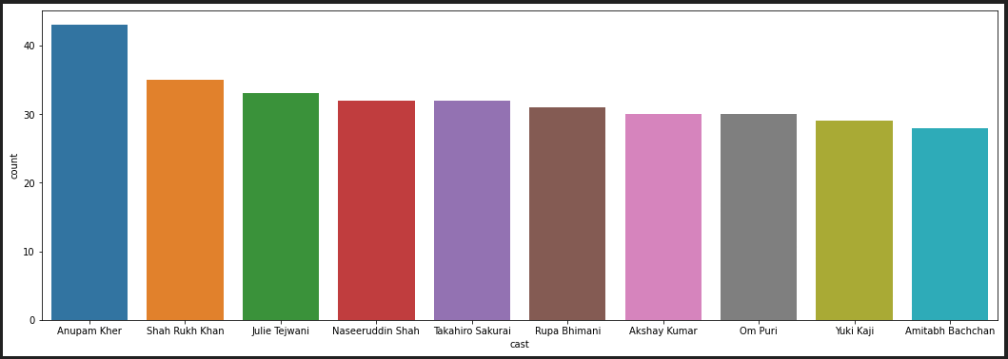

1. Rajiv Chilaka and Jan Suter are two of the most popular directors from Netflix.

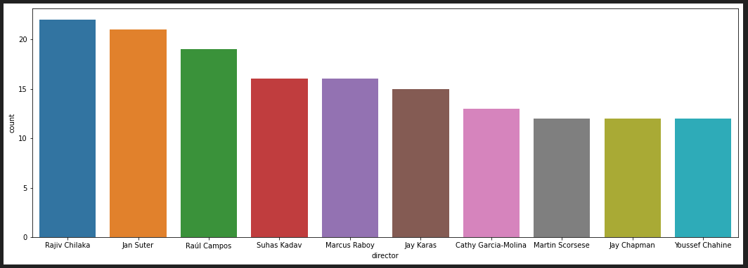

1. There are about 3500+ movies and TV shows on Netflix from US origin followed by about a 1000 from India.

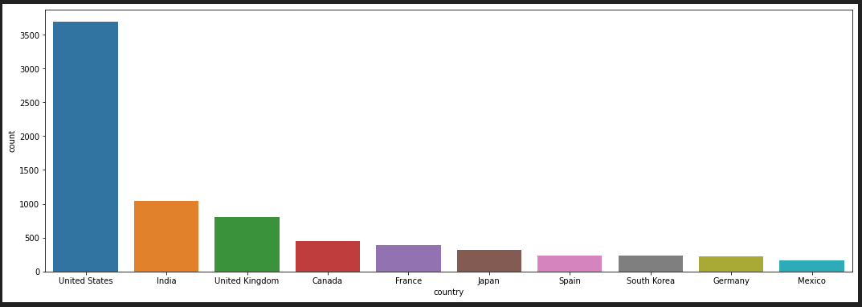

1. International Movies , Drama and Comedy are some of the most popular genres on Netflix.

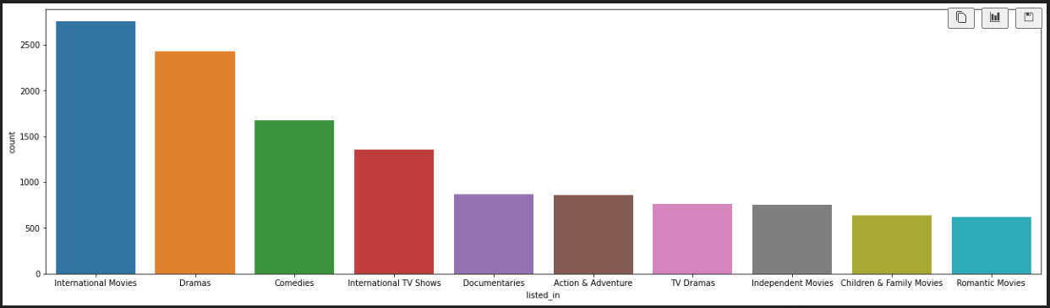

1. July and December are the two months in which most of the content is released on netflix.

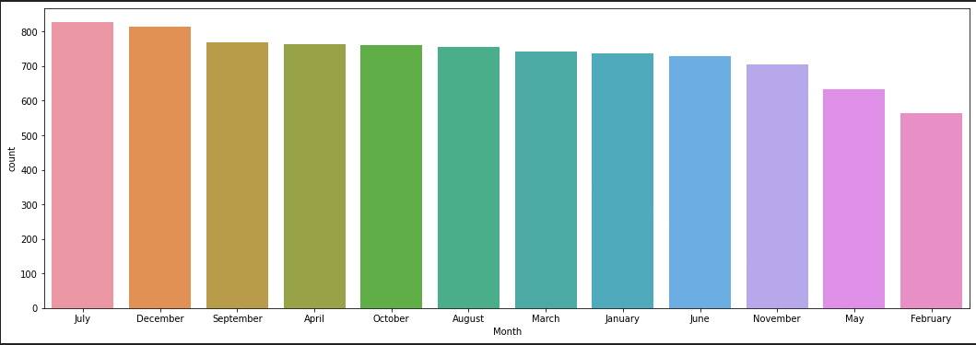

1. TV-MA and TV-14 are the most common ratings.
2. There are about twice as many movies on Netflix than TV shows.

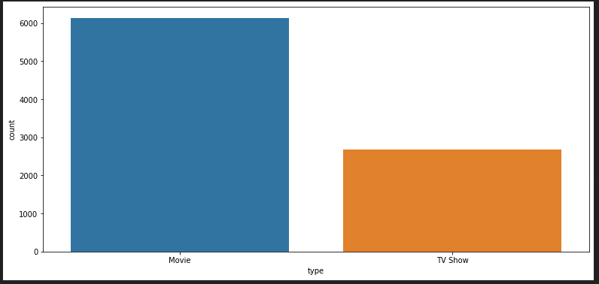

1. The best actor director combo is Fortune Feimster and Martin Scorsese.

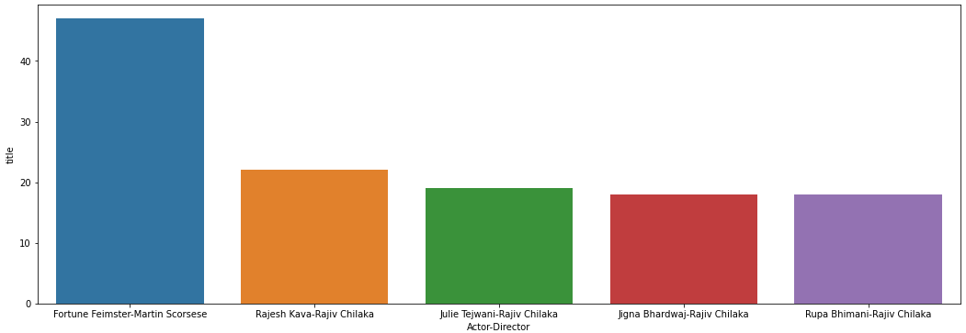

1. The number of movies released saw exponential growth after the 1990s.
2. Movies and TV Shows saw a peak in 2019-2020 and declined thereafter.

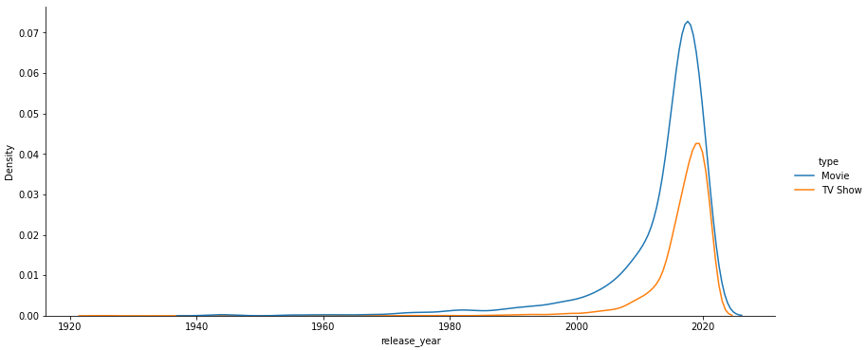

**Recommendations:**

1. US has more than 3 times more shows and movies then 2nd spot holder india. Which means that netflix business is really centered to US. They should also focus on adding more indian shows and movies to the platform to cater indian audience to minimize risk from just one country.
2. July and December are two of the most popular months, they are also holiday months around the world, so netflix can offer discounts to there customers during these months to attract more customers.
3. As the demand declined after 2019-2020 peak we can focus on creating movies and tv shows around the most popular genres like Drama and comedy.